**Course One**

# Foundations of Data Science



# Instructions

Use this PACE strategy document to record your decisions and reflections as you work through this end-of-course project. As a reminder, this document is a resource that you can reference in the future and a guide to help consider responses and reflections posed at various points throughout projects.

# Course Project Recap

Regardless of which track you have chosen to complete, your goals for this project are:

* Understand and assess the proposed scenario
* Demonstrate foundational knowledge of the data science workflow - PACE
* Articulate a data project proposal in the planning stage for cross-functional team members

# Relevant Interview Questions

Completing this end-of-course project will empower you to respond to the following interview topics:

* As a new member of a data analytics team, what steps could you take to get 'up to speed' with a current project? What steps would you take? Who would you like to meet with?
* How would you plan an analytics project?
* What steps would you take to translate a business question to an analytical solution?
* Why is actively managing data an important part of a data analytics team's responsibilities?
* What are some considerations you might need to be mindful of when reporting results?

**Reference Guide**

This project has three tasks; the following visual identifies how the stages of pace are incorporated across those tasks.

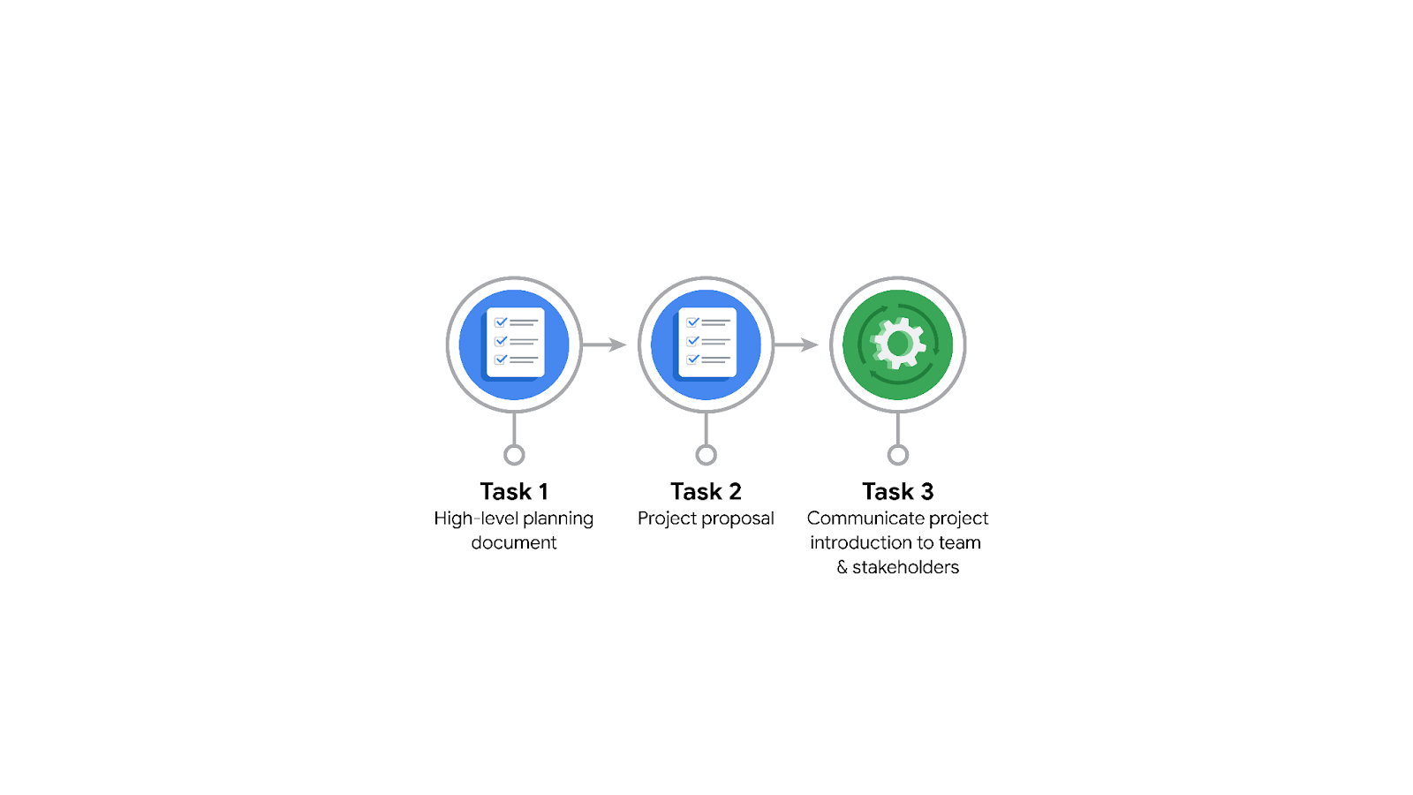

**Data Project Questions & Considerations**

******PACE: Planning Stage**

* Who is your audience for this project?
* What are you trying to solve or accomplish? And, what do you anticipate the impact of this work will be on the larger needs of the client?
* What questions need to be asked or answered?
* What resources are required to complete this project?
* What are the deliverables that will need to be created over the course of this project?

## **THE PACE WORKFLOW**

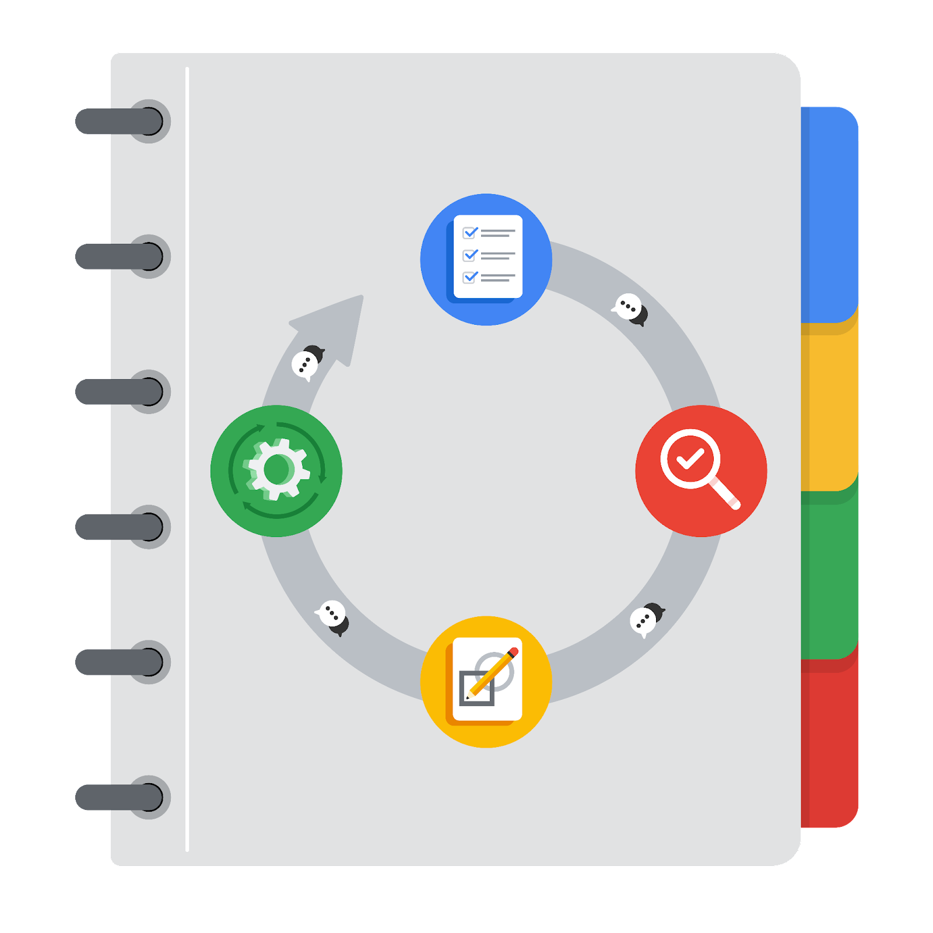

**[Alt-text: The PACE Workflow with the four stages in a circle: plan, analyze, construct, and execute.]**

You have been asked to demonstrate for the company's data team how you would use the PACE workflow to organize and classify tasks for the upcoming project. Select a PACE stage from the dropdown buttons. A few tasks involve more than one stage of the PACE workflow. Additionally, not every workplace scenario will require every task. Refer back to the [Course 1 end-of-course portfolio project overview: Automatidata](https://www.coursera.org/learn/foundations-of-data-science/supplement/XxgHa/course-1-end-of-course-portfolio-project-overview-automatidata) if you need more information about the tasks within the project.

### **Project tasks**

Following are a group of tasks your company’s data team has determined need to be completed within this project. The data analysis manager has asked you to organize these tasks in preparation for the project proposal document. First, identify which stage of the PACE workflow each task would best fit under using the drop down menu. Next, give an explanation of why you selected the stage for each task. Review the following readings to help guide your selections and explanation: [The PACE stages](https://www.coursera.org/learn/foundations-of-data-science/supplement/4OtHr/the-pace-stages) and [Communicate objectives with a project proposal](https://www.coursera.org/learn/foundations-of-data-science/supplement/79Ysh/communicate-objectives-with-a-project-proposal). You will later reorder these tasks within a project proposal.

1. **Evaluating the model: Select PACE stage**

Why did you select this stage for this task?

1. **Conduct a hypothesis test: Select PACE stage** **and** **Select PACE stage**

Why did you select these stages for this task?

1. **Understanding the data: Select PACE stage**

Why did you select this stage for this task?

1. **Data exploration and cleaning: Select PACE stage** **and Select PACE stage**

Why did you select these stages for this task?

1. **Establish structure for project workflow (PACE): Select PACE stage**

Why did you select this stage for this task?

1. **Communication insights with stakeholders: Select PACE stage**
2. **Compute descriptive statistics: Select PACE stage**

Why did you select this stage for this task?

1. **Visualization building: Select PACE stage and Select PACE stage**

Why did you select these stages for this task?

1. **Write a project proposal: Select PACE stage**

Why did you select this stage for this task?

1. **Check model assumptions: Select PACE stage**

Why did you select this stage for this task?

1. **Inspect the data set for missing data: Select PACE stage**

Why did you select this stage for this task?

1. **Build machine learning model: Select PACE stage**